**What is Visual Hierarchy?**

* Visual hierarchy is a design principle that refers to how elements are arranged in a design.
* Visual hierarchy helps designers and developers to lay out each element in a logical manner that helps the visual be digested properly.
* 12 principles of visual hierarchy that every beginner designer needs to know.

## 1 Size Impacts Visibility

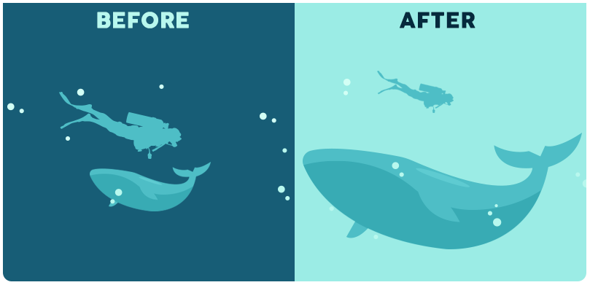

* Bigger is better, right? While the classic adage is still up for debate, **size** is arguably the most effective way to emphasize visual elements. Simply put, larger elements draw greater attention than smaller elements.
* It’s the precise reason why newspaper headlines appear in larger fonts, and major stories often have even larger headlines than articles on the rest of the page. In any design, larger elements—whether they be words or images—not only will be most noticeable, but they also will carry the strongest message.

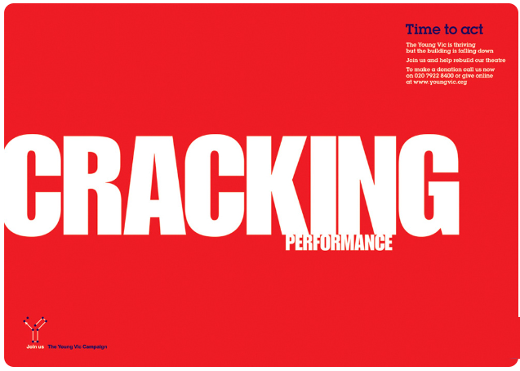

* Notice in the above example how the largest word is also the most striking and emotive. Readers are much more likely to quickly respond to the word, “cracking” than the second-largest word, the basic “performance.” The design wouldn’t be nearly as effective if the words were the same size or if another word on the page, such as “act” or “time” were even larger.
* Another important principle related to this concept is scale, which is the size of an object in relation to another. A single object, no matter how large or small, has no scale until it is compared to another.

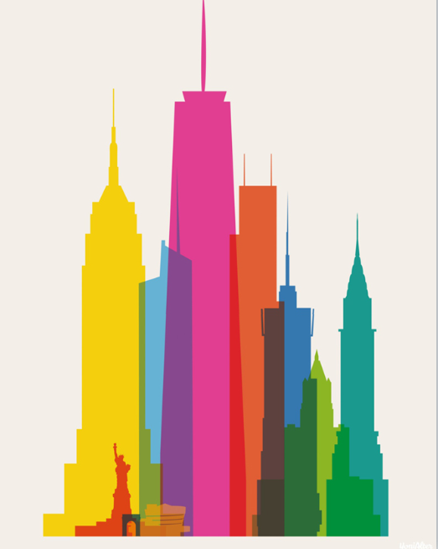

<https://visme.co/blog/visual-hierarchy/>